List
A list is a collection of elements arranged in a sequential order.
In memory, a list can be stored in two ways:
- One way is we can store the Elements are stored in contiguous memory locations. This method is known as an array.
- And the other way is we can use pointers or links to associate the elements sequentially. This method is known as a linked list.
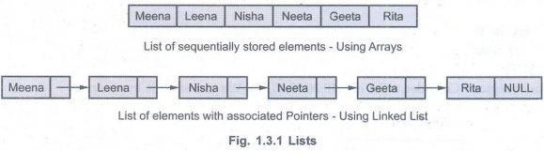

Abstract Data Type (ADT) – List
In an ADT (Abstract Data Type), the implementation details are hidden. It only defines what operations can be performed, not how they are implemented.
AbstractDataType List
{
Instances: A list is a collection of elements arranged in a linear (sequential) manner.
Operations: The various operations that can be performed on a list are:
- Insertion: Used to insert an element into the list.
- Deletion: Used to remove an element from the list.
- Searching: Used to find an element based on a given key value.
- Modification: Used to change the value of a specific element without changing its position.
- Display: Used to display the elements of the list in forward or backward order.
}

Implementation of List
A list can be implemented in two ways:
- Array-based implementation of list
Array of linked list is an important data structure used in many applications. It is an interesting structure to form a useful data structure. It combines static and dynamic structure. Static means air and dynamic linked list used to form a useful data structure this area of linked list structure is appropriate for application. Here, elements of list are stored in the (contiguous ) cells of an array. The operation that are commonly performed in list are listed below:
- Creating of a list
- Inserting new element as a required position of list
- Deletion of any element from list
- Modification of any element of list
- Traversing of list
- Merging of two list
- Linked list-based implementation of list

